# Accessing API using react.js documentation

1. In your App.js, import a useState & useEffect hocks from react to be used inside the function App():



1. useState() is a hook that is used in React addition 16.8, hooks let you use state without writing a class.

The useState() hook allows you to have state variables in a functional component,the syntax of using useState() is as follows where the first element “data” represents the initial state of the data, and “setData” is the function that is used for updating the “data” and holding all information fetched from the API.



1. useEffect is a React hook that allows you to perform side effects in function components.

Here it has been used to inform React that the component needs to do something after rendering, in our example we will use the effect hook to render the fetched data from<https://ourworldindata.org/> in JSON format.



1. fetch will return a response object of that data that has been fetched, however it's not going to be in Json format and is not accessible directly from the response object.

It's important to note that “responsive =>” makes the object responsive represent live data; meaning it will alway be up to date and any changes would be in sync with the code.

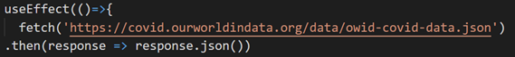

1. Similarly, “data => {setData(data)console.log(data)}” is used to make the state of data live, meaning it will update the state of the data to the newest data that has been fetched from the API.

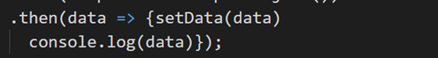

1. now the react app has access to all the API:

by checking the console, you can see all the data that is needed has already been fetched from the API.

